Longwell Green JFC-End of year newsletter

Christmas 2015

## Message from Paul Griffin-general manager of Longwell Green Sports JFC

As a club we had an amazing 2014. Did we stand still? Of course not… 2015 has seen many more achievements. It was only a couple of years ago we earned a Community Club status, the highest level available. In 2014, we became Gloucestershire Football Association Community club of the year, the ultimate accolade any club can achieve. In 2015 we were delighted to retain this title being described recently by the Gloucestershire Football Association (GFA) as Community Club Kings!

We have excelled on the coaching side via our head coach (Nigel Whittle) with coaches carrying out more development than ever before to the benefit of all of our boys and girls. Nigel will expand on this later in the newsletter.

We have ventured into soccer tots in the name of Longwell Littluns which has proved to be a big hit meaning you can now join the Longwell family from the age of 2 (more in newsletter).

We are in discussions with the GFA about creating a disabled team in 2016. This is in its early days but we are working hard to make this happen.

Our Facebook page Longwell Green Juniors FC boys and girls was only set up in the spring of 2014 and now has 550 plus 'likes’ and up to 6,000 views per week it has been an incredible success. If you have not liked the page yet, why not do so and receive all of our club news. We also have a twitter account @longwelljuniors. Follow us for tweets and retweets, club news, senior news, GFA tweets and other club tweets and retweets.

We now have around 400 boys & girls on the junior side, a number that looks likely to continue to rise as far more people join us than leave each season. As a club both our people and the club continue to receive awards from the wider community recognising all we stand for as a club.

Our web site www.longwellgreensportsjfc.co.ukcontains all our club sponsors plus much, much more so if you haven’t taken a look for a while why not visit this site.

Our end of season presentation day is booked for Saturday 14th May, so put the date in your diary. It’s a day we all come together to celebrate the season.

As one of the few clubs to hold the coveted Community Club status we will always look to move forward and I have little doubt 2016 will be another fantastic year and wish all a very happy Christmas and a prosperous new year



## C:\Users\Toby\AppData\Local\Microsoft\Windows\Temporary Internet Files\Content.IE5\W4OK0WQZ\large-Christmas-Tree-66.6-11066[1].gifC:\Users\Toby\AppData\Local\Microsoft\Windows\Temporary Internet Files\Content.IE5\W4OK0WQZ\large-Christmas-Tree-66.6-11066[1].gifC:\Users\Toby\AppData\Local\Microsoft\Windows\Temporary Internet Files\Content.IE5\W4OK0WQZ\large-Christmas-Tree-66.6-11066[1].gifC:\Users\Toby\AppData\Local\Microsoft\Windows\Temporary Internet Files\Content.IE5\W4OK0WQZ\large-Christmas-Tree-66.6-11066[1].gifC:\Users\Toby\AppData\Local\Microsoft\Windows\Temporary Internet Files\Content.IE5\W4OK0WQZ\large-Christmas-Tree-66.6-11066[1].gifC:\Users\Toby\AppData\Local\Microsoft\Windows\Temporary Internet Files\Content.IE5\W4OK0WQZ\large-Christmas-Tree-66.6-11066[1].gifLongwell LittlunsC:\Users\Toby\AppData\Local\Microsoft\Windows\Temporary Internet Files\Content.IE5\W4OK0WQZ\large-Christmas-Tree-66.6-11066[1].gifC:\Users\Toby\AppData\Local\Microsoft\Windows\Temporary Internet Files\Content.IE5\W4OK0WQZ\large-Christmas-Tree-66.6-11066[1].gifC:\Users\Toby\AppData\Local\Microsoft\Windows\Temporary Internet Files\Content.IE5\W4OK0WQZ\large-Christmas-Tree-66.6-11066[1].gifC:\Users\Toby\AppData\Local\Microsoft\Windows\Temporary Internet Files\Content.IE5\W4OK0WQZ\large-Christmas-Tree-66.6-11066[1].gifC:\Users\Toby\AppData\Local\Microsoft\Windows\Temporary Internet Files\Content.IE5\W4OK0WQZ\large-Christmas-Tree-66.6-11066[1].gifC:\Users\Toby\AppData\Local\Microsoft\Windows\Temporary Internet Files\Content.IE5\W4OK0WQZ\large-Christmas-Tree-66.6-11066[1].gif

**With our younger groups proving so popular the idea came up to create a soccer tots group. It was just an idea a few months ago but it is now a reality with 10 sessions running on Sunday mornings up until Christmas (and a further 10 already booked for 2016). In no time at all, we have grown to around 40 boys and girls and as a result can now provide football training from 2 years old up within the Longwell family. The learning will set these boys and girls up perfectly for when they hopefully join our under 5 group in the future. Big thanks to Jamie for helping me each week. He received an award in the young coach of the year category at the West of England Sports Awards. Final thanks to all the Mums and Dads who get up early to come along each week.**

**There is still chance to join. Just contact us via the web site or message us Facebook page to arrange to come along.**

**Paul Griffin**

## C:\Users\Toby\AppData\Local\Microsoft\Windows\Temporary Internet Files\Content.IE5\TCGYL2JN\large-Christmas-Tree-166.6-11066[1].gifC:\Users\Toby\AppData\Local\Microsoft\Windows\Temporary Internet Files\Content.IE5\TCGYL2JN\large-Christmas-Tree-166.6-11066[1].gifC:\Users\Toby\AppData\Local\Microsoft\Windows\Temporary Internet Files\Content.IE5\TCGYL2JN\large-Christmas-Tree-166.6-11066[1].gifC:\Users\Toby\AppData\Local\Microsoft\Windows\Temporary Internet Files\Content.IE5\TCGYL2JN\large-Christmas-Tree-166.6-11066[1].gifC:\Users\Toby\AppData\Local\Microsoft\Windows\Temporary Internet Files\Content.IE5\TCGYL2JN\large-Christmas-Tree-166.6-11066[1].gifC:\Users\Toby\AppData\Local\Microsoft\Windows\Temporary Internet Files\Content.IE5\TCGYL2JN\large-Christmas-Tree-166.6-11066[1].gifC:\Users\Toby\AppData\Local\Microsoft\Windows\Temporary Internet Files\Content.IE5\TCGYL2JN\large-Christmas-Tree-166.6-11066[1].gifUnder 5’sC:\Users\Toby\AppData\Local\Microsoft\Windows\Temporary Internet Files\Content.IE5\TCGYL2JN\large-Christmas-Tree-166.6-11066[1].gifC:\Users\Toby\AppData\Local\Microsoft\Windows\Temporary Internet Files\Content.IE5\TCGYL2JN\large-Christmas-Tree-166.6-11066[1].gifC:\Users\Toby\AppData\Local\Microsoft\Windows\Temporary Internet Files\Content.IE5\TCGYL2JN\large-Christmas-Tree-166.6-11066[1].gifC:\Users\Toby\AppData\Local\Microsoft\Windows\Temporary Internet Files\Content.IE5\TCGYL2JN\large-Christmas-Tree-166.6-11066[1].gifC:\Users\Toby\AppData\Local\Microsoft\Windows\Temporary Internet Files\Content.IE5\TCGYL2JN\large-Christmas-Tree-166.6-11066[1].gifC:\Users\Toby\AppData\Local\Microsoft\Windows\Temporary Internet Files\Content.IE5\TCGYL2JN\large-Christmas-Tree-166.6-11066[1].gifC:\Users\Toby\AppData\Local\Microsoft\Windows\Temporary Internet Files\Content.IE5\TCGYL2JN\large-Christmas-Tree-166.6-11066[1].gif

**Our newest Under5 group has only been running for a few months but the boys have already improved so much. We currently have around 30 in the group and I am sure that will grow. The boys listen well and are very organised. They are often ready for the next drill before we have even explained it. So far we have focussed on basic skills which the boys have picked up so well and as we move on through their first year will introduce more drills in little groups.**

**Big thanks to Matt & Jamie for all they have done. We also have a couple of Dads who have offered to help as we move forward and who are already assisting at training so big thanks to them. A final thanks to all the parents who bring the boys early every Saturday. As the weather turns wintery you will find us training in the cold and wet, very rarely cancelling training so your support is appreciated.**

**A great start and I have little doubt a great future ahead well done to all the boys**

**Paul Griffin**

## C:\Users\Toby\AppData\Local\Microsoft\Windows\Temporary Internet Files\Content.IE5\PMDPQLEP\large-Christmas-Tree-0-11066[1].gifC:\Users\Toby\AppData\Local\Microsoft\Windows\Temporary Internet Files\Content.IE5\PMDPQLEP\large-Christmas-Tree-0-11066[1].gifC:\Users\Toby\AppData\Local\Microsoft\Windows\Temporary Internet Files\Content.IE5\PMDPQLEP\large-Christmas-Tree-0-11066[1].gifC:\Users\Toby\AppData\Local\Microsoft\Windows\Temporary Internet Files\Content.IE5\PMDPQLEP\large-Christmas-Tree-0-11066[1].gifC:\Users\Toby\AppData\Local\Microsoft\Windows\Temporary Internet Files\Content.IE5\PMDPQLEP\large-Christmas-Tree-0-11066[1].gifC:\Users\Toby\AppData\Local\Microsoft\Windows\Temporary Internet Files\Content.IE5\PMDPQLEP\large-Christmas-Tree-0-11066[1].gifC:\Users\Toby\AppData\Local\Microsoft\Windows\Temporary Internet Files\Content.IE5\PMDPQLEP\large-Christmas-Tree-0-11066[1].gifUnder 6’sC:\Users\Toby\AppData\Local\Microsoft\Windows\Temporary Internet Files\Content.IE5\PMDPQLEP\large-Christmas-Tree-0-11066[1].gifC:\Users\Toby\AppData\Local\Microsoft\Windows\Temporary Internet Files\Content.IE5\PMDPQLEP\large-Christmas-Tree-0-11066[1].gifC:\Users\Toby\AppData\Local\Microsoft\Windows\Temporary Internet Files\Content.IE5\PMDPQLEP\large-Christmas-Tree-0-11066[1].gifC:\Users\Toby\AppData\Local\Microsoft\Windows\Temporary Internet Files\Content.IE5\PMDPQLEP\large-Christmas-Tree-0-11066[1].gifC:\Users\Toby\AppData\Local\Microsoft\Windows\Temporary Internet Files\Content.IE5\PMDPQLEP\large-Christmas-Tree-0-11066[1].gifC:\Users\Toby\AppData\Local\Microsoft\Windows\Temporary Internet Files\Content.IE5\PMDPQLEP\large-Christmas-Tree-0-11066[1].gifC:\Users\Toby\AppData\Local\Microsoft\Windows\Temporary Internet Files\Content.IE5\PMDPQLEP\large-Christmas-Tree-0-11066[1].gif

## Under 6's - quantity and quality. A large group, full of talented young footballers. There 45 registered players most of whom are at training every week, which always makes for lively sessions. The quality for such young players is amazing. It is easy to forget their age as we watch them perform drills to such a high standard week in week out. In the last season before commencing friendly matches, it is clear that next step cannot come soon enough. With the bad weather now upon us the numbers at training have barely changed which is a credit to the dedication of the boys, girls and parents. Not forgetting the coaches Adam, Sean, Andy, Jason, Jamie & Jake who turn up every week whatever the weather putting on sessions for the group. The future looks very safe in their hands. The age group has a bright future ahead with I have no doubt many years of enjoyable football to come as part of the Longwell family. We look forward to presentation day when we can celebrate the season together and all that we have achieved and meanwhile hope all have an enjoyable Christmas and Happy new year.

Paul Griffin

## C:\Users\Toby\AppData\Local\Microsoft\Windows\Temporary Internet Files\Content.IE5\W4OK0WQZ\clipart0221[1].jpgC:\Users\Toby\AppData\Local\Microsoft\Windows\Temporary Internet Files\Content.IE5\W4OK0WQZ\clipart0221[1].jpgUnder 10 girls (team and development squad)C:\Users\Toby\AppData\Local\Microsoft\Windows\Temporary Internet Files\Content.IE5\W4OK0WQZ\clipart0221[1].jpg C:\Users\Toby\AppData\Local\Microsoft\Windows\Temporary Internet Files\Content.IE5\W4OK0WQZ\clipart0221[1].jpg

Merry Christmas and a Happy New Year

To all the players, coaches and everyone involved with Longwell Green Sports JFC from the Girls U10’s Team& Development Squad.

The new U10’s girls’ team have started well in their first season in the Bristol Girls League and are really enjoying playing match football. Matt and Kevin are glad to have such an enthusiastic group of girls to work with at training and on match days and they have created a fantastic friendly, fun team environment. We look forward to many successful seasons ahead.

If there are any current school year 3 or 4 girls out there that would be interested in joining the Development Squad at this friendly club please contact Matt Draper (07788565095). Ready to potentially form the next U10’s girls’ team.

Training is 11 – 12 on a Saturday morning at SBL Sports Centre, Oldland Common.

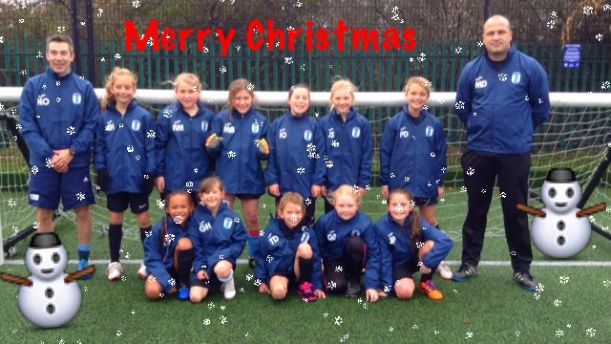

Under 16 Division 3C:\Program Files (x86)\Microsoft Office\MEDIA\CAGCAT10\j0183290.wmf

So far this season I have experienced the complete highs and lows of football management. From equalising with the last kick of the game v Timsbury (champions elect) my happiest day in football since The Baggies great escape!

To conceding 16 goals in 2 games in the space of a week!!! One minute I feel like Fergie the next I feel like McLaren!!!! At times the lads have played like Brazil other times not so good!!!They are a great set of lads and I expect some good results between now and the end of the season. 32 of us are off to our annual Christmas get together this coming Sunday (6th) for a game of FOOTGOLF, a really great turn out I reckon. Thanks to all parents for their help on match days, I hope to thank you with a few good performances before the end of the season.

Merry Christmas and a happy new year to you all

Cheers

Ian

## Under 11 lionsC:\Users\Toby\AppData\Local\Microsoft\Windows\Temporary Internet Files\Content.IE5\14XYDUAY\present-307775_640[1].pngC:\Users\Toby\AppData\Local\Microsoft\Windows\Temporary Internet Files\Content.IE5\TCGYL2JN\present-147168_640[1].png

-

Since forming Longwell Lions U11 in the summer, the squad has grown to 13 players and we are making good progress. The emphasis is on having fun and developing as individuals, as well as working for the team. Our three most recent players have all played a key part in development and cup matches, with the squad all showing great attitude whether selected to start or not. We are lucky to have supportive parents, who amongst other jobs, cheer from the side-lines, run the line, manage the finances and take down the goals at full time, amongst other jobs! Our focus in now on being competitive in matches, so we show how well we can pass the ball and get what we deserve. The players are benefitting from a midweek fitness session at a local gym, which helps them to cope with the physical demands of heavier pitches at this time of year. We are having a Christmas event at Airhop (where else?) and a festive friendly against Bitton!

Merry Christmas and a Happy New Year to everyone at Longwell Green Juniors.

## Under 9 boysC:\Users\Toby\AppData\Local\Microsoft\Windows\Temporary Internet Files\Content.IE5\TCGYL2JN\5221106861_9f1b0ccf72_z[1].jpg

As well as being another great year on the pitch for our U9’s, it’s been a great year for other things too. Our Christmas party last year was another great night with food, drinks, karaoke and games. All the boys, parents and family members had a great night. We ventured on tour for the 1st time with a trip to the Isle of Wight in May and everyone had a fantastic time bonding. So much so, we’ve already booked next year’s tour! In the summer we took part in 3 tournaments, Brislington, Ashton and Whitchurch, all giving experience and challenges to the boys who took part. Since the season started, we have held a couple of social events, both for parents and the boys. In September the parents met for drinks and Indian food at the Barrs Court Spice Lounge. In October, all the boys met for Halloween at one of our parent’s house. Whilst the boys played football in the garden, the adults were treated to drinks and curry in the warm (thanks Scott and Alex). On the coaching side, our coaches have worked to develop their own skills, Matt taking his YAM2 in February and Nige and Andy taking their YAM2 in November. All in all, a great year for the U9’s. Here’s to 2016……….



**Under 8 colts**

This season, we had a change in Manager with Neil deciding to step down; the coaching team were joined by local ex-ref John Ridler. Since the summer we have seen the number of players signed on to the team grow to 23. The emphasis this season has been to build and develop as a team. With new players, coming into the team and establishing themselves we have started to grow and strengthen the squad. Training session can be chaotic at times, over run and often we appear to be the loudest team on the training pitch but with 23 enthusiastic players, I do not think you can expect anything less. We have recently taken part in the Saltford Santa dash to help raise money for the local charities and also the team as well as holding our Christmas party at Laser Fusion in Bristol where the players could all let off steam.

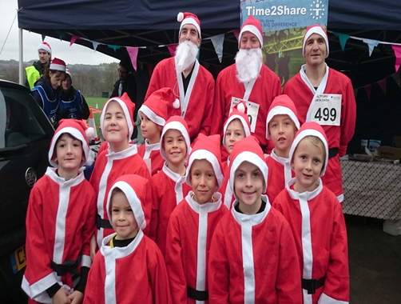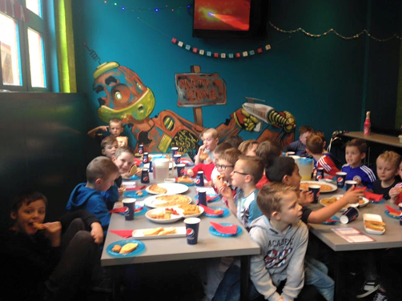

## C:\Users\Toby\AppData\Local\Microsoft\Windows\Temporary Internet Files\Content.IE5\W4OK0WQZ\christmass-bulbs[1].pngC:\Users\Toby\AppData\Local\Microsoft\Windows\Temporary Internet Files\Content.IE5\W4OK0WQZ\christmass-bulbs[1].pngLongwell Green under 13s (White squad) GirlsC:\Users\Toby\AppData\Local\Microsoft\Windows\Temporary Internet Files\Content.IE5\W4OK0WQZ\christmass-bulbs[1].pngC:\Users\Toby\AppData\Local\Microsoft\Windows\Temporary Internet Files\Content.IE5\W4OK0WQZ\christmass-bulbs[1].png

We again are having a good season with yet more improvement on last season and I wanted to know why the girls enjoy playing for the team and here are some of their responses:

* I feel welcomed when I come to play or train, I have made friends instantly and my coaches push me to the full in order to be the best goalkeeper I can possibly be, they also teach me new skills each week. – Briony
* The team get along (like a family) and even when we lose we all encourage each other and the coaches (Mike, Simon & Mark) have faith in us, so we have faith in ourselves that’s why we want to play every Sunday – Olivia
* It’s fun to play different teams and I look forward to playing every weekend - Gina
* Because we make new friends and you’re out getting exercise and I like to win! – Ella
* I really enjoy playing football and like playing games at different venues/places – Alex
* I love playing football with the other girls and I have lots of fun at training – Lucy
* I like the coaching because it teaches me new skills and enjoy the support that we get at our games – Emily
* The coaches and the other girls are really nice and it feels like one big family - Chiara

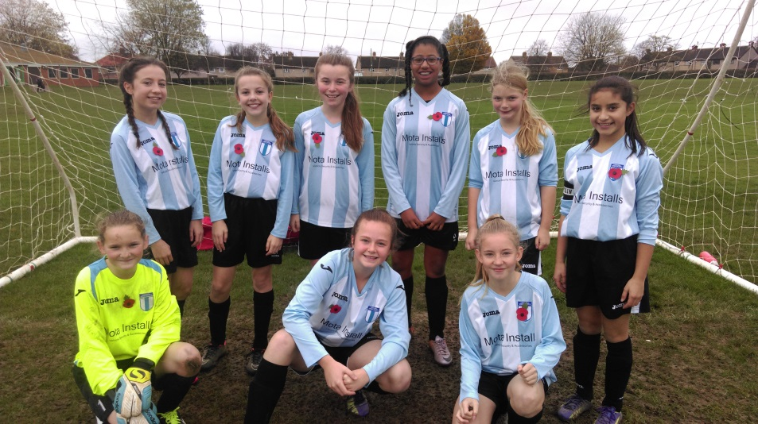

## These are the under 13 girls (white squad)

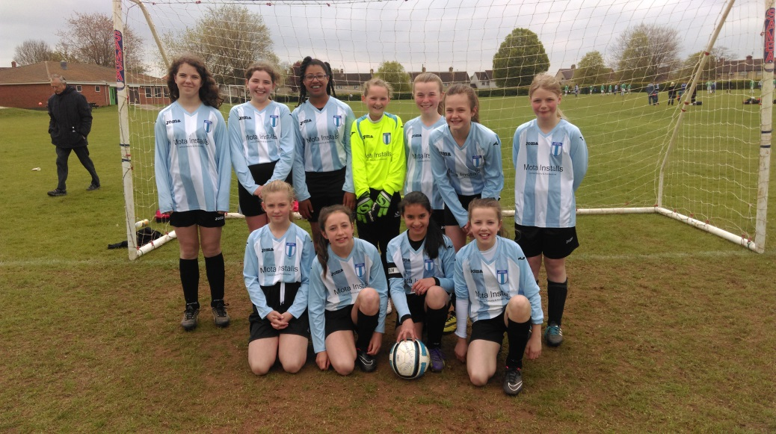

## C:\Users\Toby\AppData\Local\Microsoft\Windows\Temporary Internet Files\Content.IE5\TCGYL2JN\large-Christmas-Decoration-0-14285[1].gifLongwell Green U10 ColtsC:\Users\Toby\AppData\Local\Microsoft\Windows\Temporary Internet Files\Content.IE5\TCGYL2JN\large-Christmas-Decoration-66.6-14285[1].gif

Our season got off to a fantastic start, with both our sides getting to the plate final of Emersons Green 7 a side summer tournament. It was a great game, which ended 2 - 2 after extra time and meant we had to decide the result with penalties. We sent all the boys up to collect the trophy and medals and it was brilliant to see them all celebrate their success. It was a great send off for Scott Gardiner who finished his manager role in the summer, the boys did him proud that day!!

We have also added Nick Harvey and Andy Bowman as coaches and they are helping out with training and match days which makes everything work very well. The team have been playing some superb football and the parents, grandparents and other supporters keep telling me how good the passing and teamwork is and that is all down to how hard the boys work on their skills during training. All the boys have taken a turn in goal this season and they are all trying different positions during the development and competitive games. Our results continue to show that the Colts are coming on "leaps and bounds" and it is only the wet weather in November that has stopped us from adding to the successes in September and October.

The new season has started well. We got a new kit with Capita Asset Services agreeing to be our sponsor.

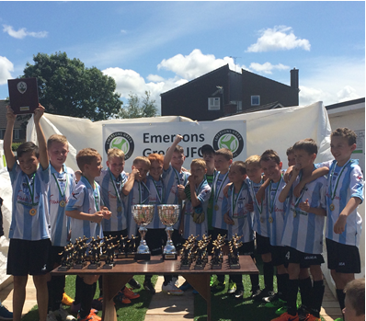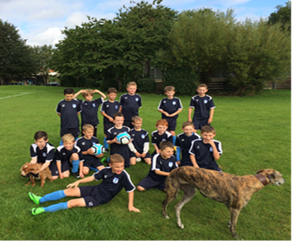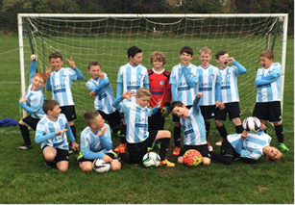

Players view

I like playing for Longwell Green because when I was looking for a new club to play for I went to a few clubs but did not like how they were training it didn't look very interesting so I came here and really enjoyed the training and the boys and coaches are great to. I also find that as well as serious times like the games we have also some fun times to, we have a great relationship still we all the players and coaches. From Jack Lewis (player)

We also held a brilliantly organised quiz night led by Kate Crees and raised enough funds to buy a new training kit. Adam, Nick, Andy and all the U10 Colts.

. 

**Under 15 Girl’s**

Wow, what a season so far…. We played one pre-season friendly days before the start of our season and unfortunately we struggled, showed very little desire and lost heavily… After much consideration and with much sadness Stuart felt another season struggling for numbers and results would be too much for all and folded the team… He managed to encourage all the girls still keen to play to train with other local clubs.

Before we move on, can I say a big thank you to Stuart for all his efforts keeping the team alive and passing on all his knowledge and coaching experience over the years to a very entertaining group of girls… He is sorely missed..

Now, this is where I have had to step up to the plate… Helping Stuart out where ever I could has always been a pleasure but taking on a team was never my idea of fun ☺… So my daughter and initially six others headed to another team for training… Week 1 they weren’t over keen but all us parents encouraged them to try again next week… Week 2 unfortunately they were still not keen and five of these girls approached me and asked if I would just take them training once a week as they didn’t want to continue playing for another team…

After a couple of long days I made the decision to contact all the girls/parents to see who would be keen to revive the Longwell Green team and if any friends could be encouraged… What a response…. Nine of the eleven who played in the pre-season friendly were straight back and two of these had talked friends into coming along… At that point I knew there was no turning back… At this point we were three weeks into the season so when I spoke with the league they couldn’t have been more accommodating in welcoming us back in and were also delighted we had encouraged the girls to keep playing and keep another team alive..

Our first game back and we had nine players available and no goalie… However, the team spirit we have, encouraged one of our girls from last year to offer to sign on and go in goal when needed… What a star… We played with 10 and although looked a little rusty came in at half time 1-0 up…. It was at this point I thought I should resign quickly and take all the credit ☺, but again the girls kept pushing me on… Unfortunately we lost the second half and the final result was 4-1 but the spirit the girls showed has **NEVER** dropped since this first game.

Unfortunately there are some very good teams team’s in our league, most with large squad numbers but we have managed to recruit and now have a healthy 14 signed on.. We are progressing all the time and with 5 new players to the team it will always get better as we all “gel” and learn..

The girls enjoyment when playing football makes it all worthwhile and I can only thank them for their efforts and wish them a very “Happy Christmas” and a very hopeful New Year…

Finally can I say thank you to all the parents for their help and especially John Lester and Neil Todd for the assistance they have provided me in getting the team where they are today…. Also there is definitely one person who never gets a mention (the referee) and in our case this is Toby Clifton… He turns up every home game for us looking stunning, smelling of mighty familiar cologne and putting the girls off with his good looks (apparently☺) but is always fair and professional. Without Toby we would be unable to play, so special thanks there TC…

**“Merry Christmas and a Happy New Year” to all and Good Luck to all Longwell teams in 2016**

**Mark Sprules** [](http://www.google.co.uk/url?sa=i&rct=j&q=&esrc=s&source=images&cd=&ved=0ahUKEwia7pXTqe_JAhWCShQKHQ9VAzEQjRwIBw&url=http://www.funnyordie.com/articles/dec3e55d26/unnecessary-tribute-woody-harrelson-the-greatest-movie-athlete-of-all-time&psig=AFQjCNGY69ApP_yB3vCnjacB35_E8MH2FQ&ust=1450868800100068)

**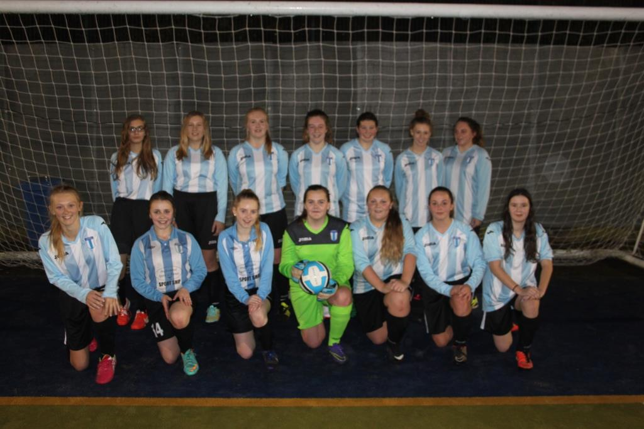**

**Under 14 colts**

Much has been happening in the u14 colts’ camp since last Christmas,

We had a very successful and very enjoyable bubble football party.

It was excellent to see the boys enjoying themselves whilst (fairly safely) knocking 7 bells out of each other. Some of us parents and coaches had a short go whilst the boys were catching their breath and I must say I would thoroughly recommend it to players and parents.

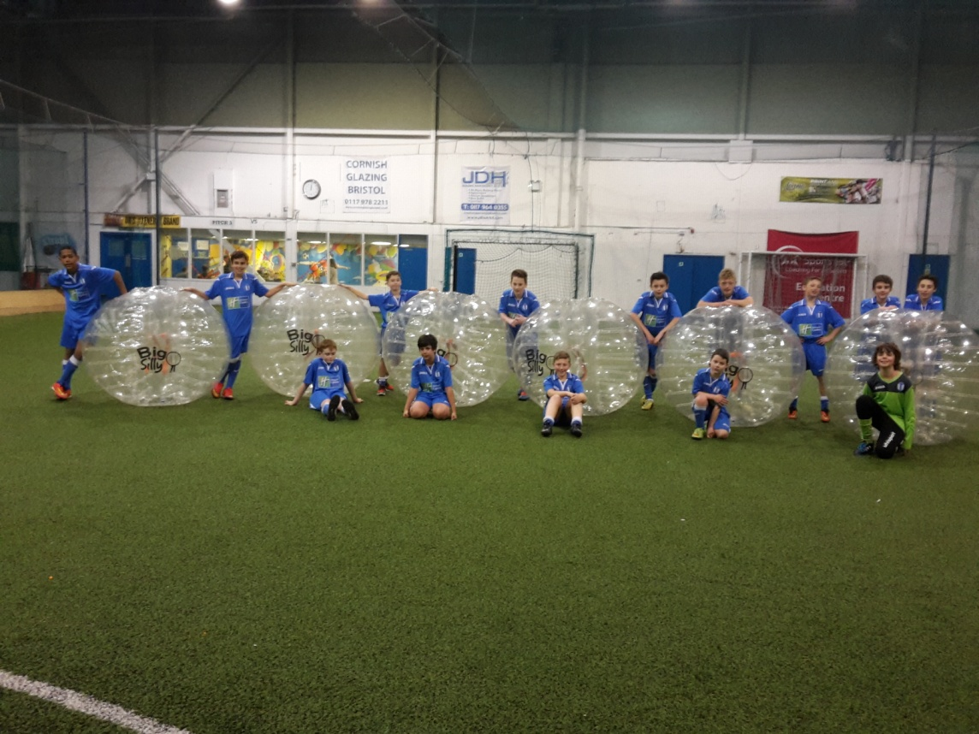

We had a very successful and very enjoyable summer tour.

Our tour took us to Warmwell Holiday Park in Weymouth and everyone agreed the facilities were exceptional and the staff very helpful and accommodating, even allowing us our own space near the football pitch and outdoor sports area to hold our own BBQ for the afternoon.

The football tournament itself was played on Dorchester Town 1st team pitch split into 3 smaller pitches. The tournament was very well run and all games ran as scheduled without much delay. To finish off an excellent days football, one of the 2 teams we entered came away as tournament winners and we are happy and excited to already have 2 team places allocated for the end of this season to try and defend our title. The tour must have been a success as most families that attended rebooked their lodges for 2016 before leaving that weekend. Something I and am sure everyone else involved is very much looking forward to again next summer.

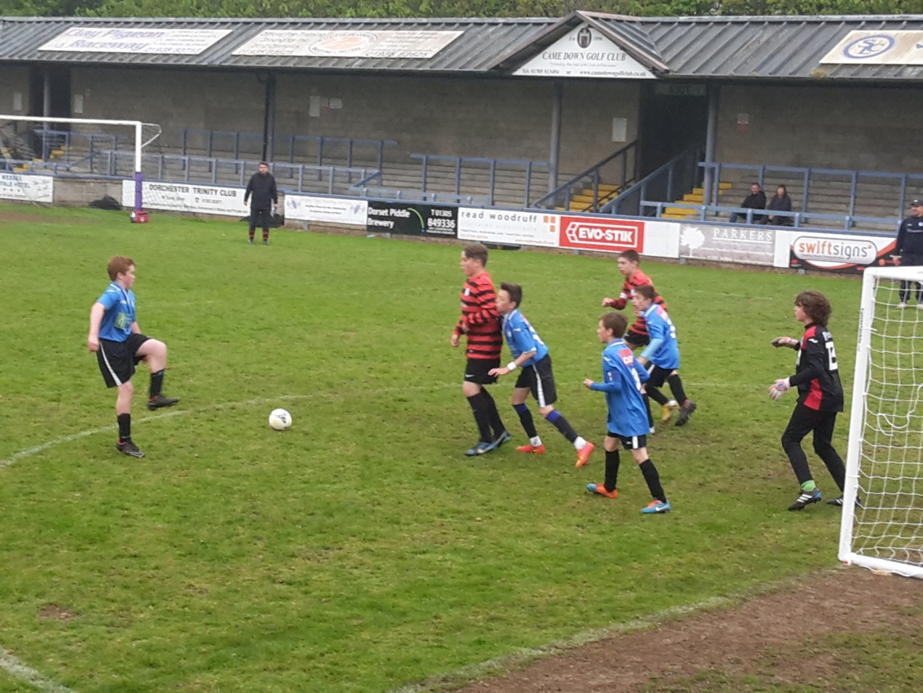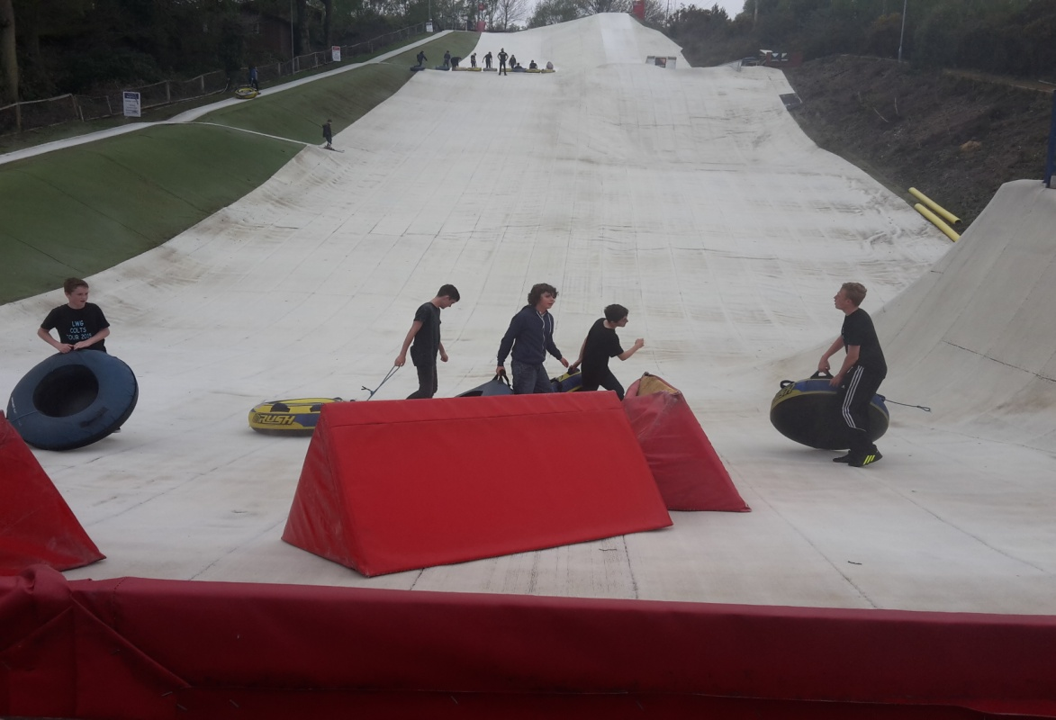

Season

I must admit, I couldn’t have wished for a better start to the season carrying on our unbeaten league run from the end of last season into an 11 game winning streak but unfortunately, all good things must come to an end and we were narrowly beaten for the first time this season in the league 2-1.

We are currently running a comfortable 2nd in the table with one more game before the Christmas break. If we continue with current form, there is no reason we shouldn’t finish lower than 2nd but with a little luck we may be able to sneak the top spot, only time, of course, will tell.

Training

I have to be honest I am blessed to have such a great bunch of lads to work with, a very good bunch of parents that support myself and the other coaches in the decisions we make surrounding the boys development, and wow, have they developed over the last 12 months.

Personally, I believe some of the development skills have been increased by an extra weekly training session of Futsal. The boys love it and they’re confidence on and off the ball has improved 10 fold. With some fundraising help from our parents we have been lucky enough to purchase our own set of Futsal nets which also come in very handy for summer training sessions on the grass.

I would also like to thank the parents, in particular Jeff Saunders, for agreeing to arrange a linesman rota for us, which really takes some of the pressure of us coaches, and for the continued support throughout the season on match days come rain or shine.

The coaches with me this season have really held the fort together during my continued visits and stays in hospital throughout the year. A very big thanks to Kev, Chris and Phil for putting together good training sessions in my absence, which have been quite a few, but hopefully less in the New Year.

Social Evening

We had a very enjoyable night recently at The Fiddlers Club in Bedminster. A very quiet and sophisticated affair watching Doreen Doreen and I’m pretty sure there weren’t many SHOTS being consumed during the evening.

Looking Forward

As mentioned previous, we already have our Summer Tour in place for 2016.

I am hoping to get some Futsal games and tournaments organised for the boys.

I am hoping to continue my development as a coach with several coaching courses I intend to complete.

And I intend to stay out of hospital as much as possible.

Lastly, may I and everyone involved with the u14’s colts, wish everyone a very Merry Christmas and a Happy New Year. May all your footballing dreams come true.

Paul, Kev, Chris, Phil and the u14’s Colts.

****Coaches Corner****

Welcome to the Xmas edition of “Coaches Corner”.

2015 has been a fantastic year for Longwell Green Juniors. We’ve achieved so much this year and we have plans to do more in 2016. In a recent meeting with the Regional Grassroots senior coaching tutor, he said “his challenge this year was to get all other local clubs to the Longwell Green standard” quite a testament I’m sure you’ll agree.

Our challenge now is to maintain this standard in 2016. There is an old saying “to stand still, is to fall behind” We’re really keen as a club to ensure this does not happen so I hope you will all join me in continuing our personal development both as a club and individually. This involves parents, players, coaches and managers.

Here is a reminder of what we’ve achieved in 2015:

•Finished our 1st year’s FA Mentoring with Steve Lilley •Rolled out our Club Philosophy and DNA

•Introduced a coaching session on the agenda at monthly meetings •Held regular coaches’ sessions

•Head Coach Communications •Dedicated Goal Keeping Coaching •Introduced “Littluns” Coaching

•Attended the FA Regional Coaches Event • Spoke at the FA’s Mentoring Launch for 2016 •Lots of CPD for our coaches

2016 will be no different and we have some excellent plans to take us to the new level. Here are just some of the things we are looking to introduce in 2016:

•Continue with the FA Mentoring Programme working with a new FA Coach •be the first local club to include disabled coaching

•Continue with our club Mentors and do even more •Roll out Mentor Blogs / videos

•Hold an introductory session in Jan / Feb for all parents who might want to become managers / coaches

•Look for the next batch of Mentors •Futsal coaching •Goal Keeping Coaching

We’re working really hard to improve the standard of coaching at the club and a number of our coaches and managers have recently taken coaching badges including GFA Level 1, Youth Module 1 and 2. This keeps us at the very front of local clubs. We should be really proud of what we have and work hard to continue this progress during 2016. I would like to thank all the coaches and managers who work hard to provide excellent coaching for children right across the community. We now have over 400 kids playing football for Longwell Green. With over 60 coaches, we have a wealth of experience and our 4 club mentors are there to support and help improve coaching right from our least experienced coaches right up to the most experienced. You are never too old to improve!

Merry Christmas and a Happy New Year

Nige

Head Coach



**Under 16 boys Division 4**

“Longwell Green Under 16 Sports finished last season on a low, having lost all their games in the season. However despite this, the majority of the boys stuck at it and renewed their membership for the current season, this year we have held a Fun Training Day that included the boys training all day through the heat of summer and spirits have definitely picked up with the usual laughter and banter that one can only expect from 15-16 year old teenagers returning!! This season so far the standard of football being played is far better than that of last season and this has reflected in more goals being scored. Unfortunately results have not gone our way but there has been a couple of close calls, you would think this would lower the lads spirits, but no! This has shown a real test of their character, instead of putting their heads down and groaning, like so many would, they turn upp to training wweek in week out, they are evening bringing their mates along to try out to give us more options on the pitch – A real mark of professionalism.

We are very proud of each and every player, although results have not gone our way (YET!!) they are all an absolute pleasure to work with and coach and we wish them all a very Merry Christmas……but not too many mince pies!!.”

**Under 12 colts**

We started this season struggling to get a full team we have gone on to get a great group of boys, we are really coming together as a team and looking forward to all our matches. We would like to thank all our boys and their families for the positive and enthusiastic attitude shown throughout this season, enjoy the remaining games and the fast approaching Christmas party. Season greetings to all.

Tony, Steve, Maria longwell green u12 colts

**Under 13 boys**

We finished last season at 9 aside on a high with as runners up in the B Division of the Avon Youth League.

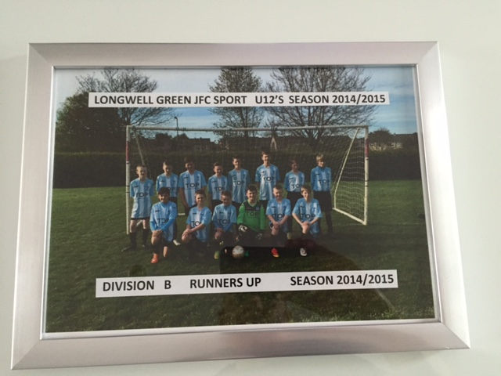

What gave us a really good start to the New Year was an impromptu training session lead by James Horrocks and Dave Tomlin, the weather was awful and puddles filled Shellards road pitches. In pairs the boys were put through their paces, they were covered in mud and really enjoyed the session.

This season we are competitively placed in the top third of the B division with games in hand, so James and Dave we need another training session.

On Saturday 28 November many of the team took part in the 5k Park Run at Pomphrey hill. This is an organised run which takes place at 9am every Saturday morning. Our weekend game had been cancelled due to poor weather and therefore we took the opportunity to take part. 11 boys took part and did a fantastic job, every one of them finished.

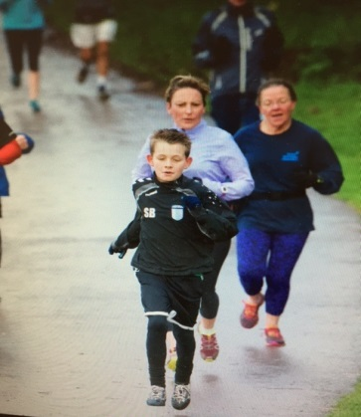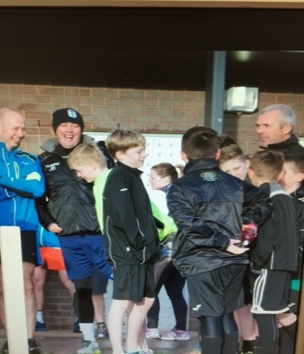

This was a great team building exercise with everyone encouraging one another. We finished the morning with a cup of tea and bacon sandwich.

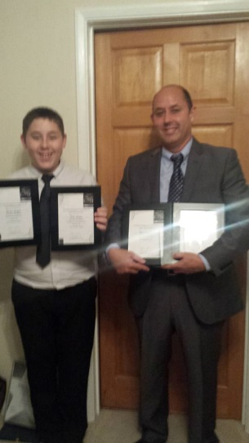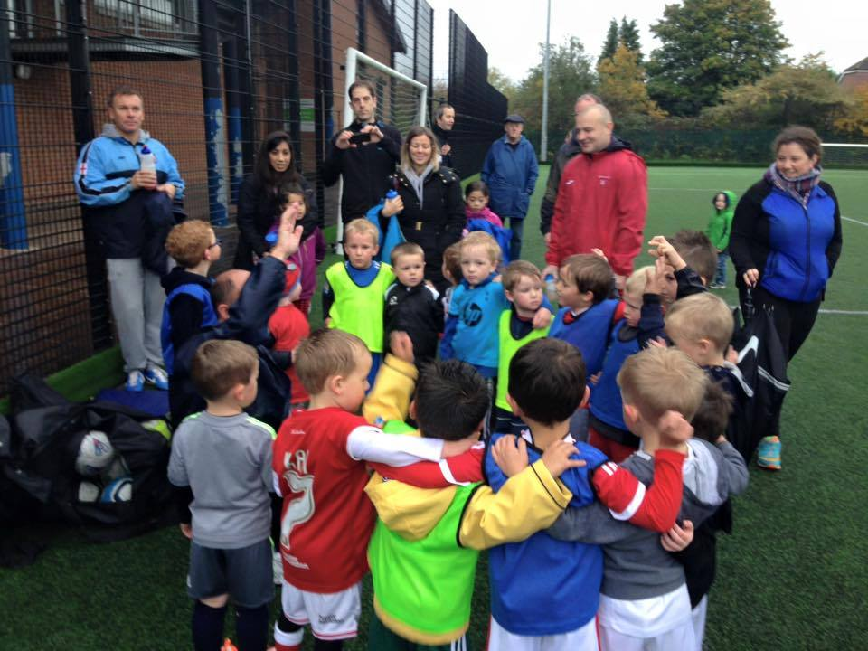

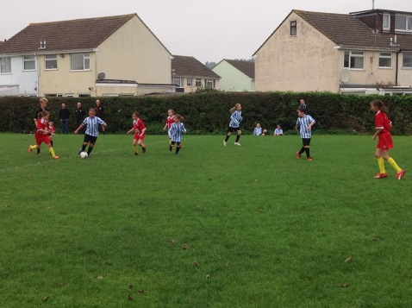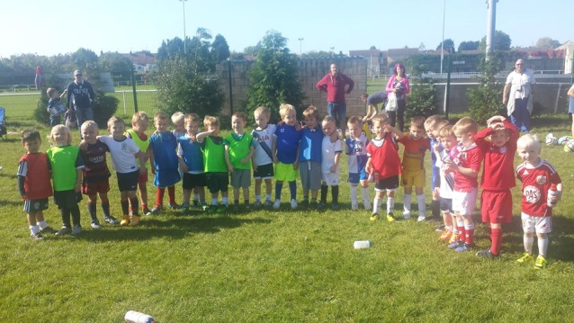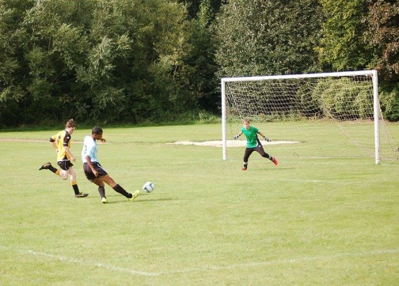

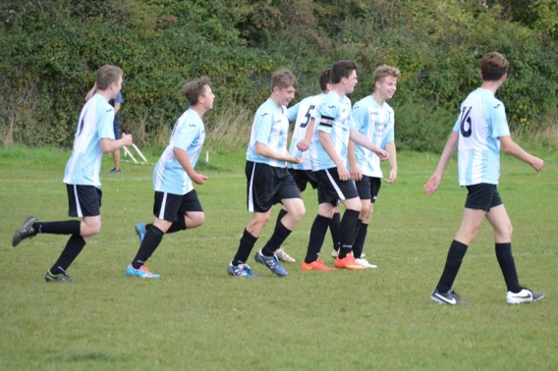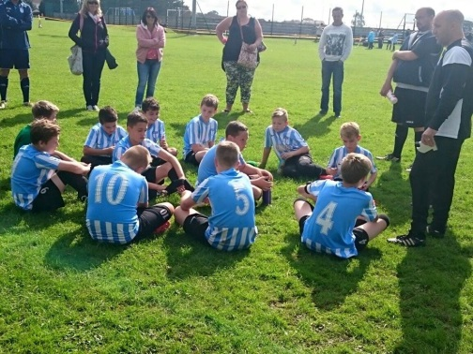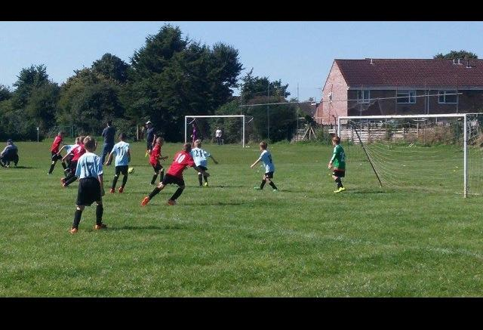

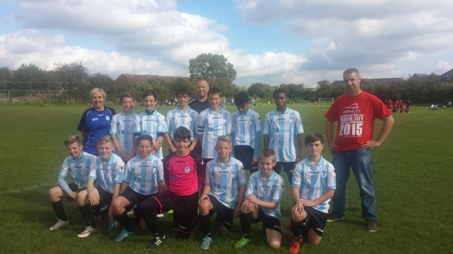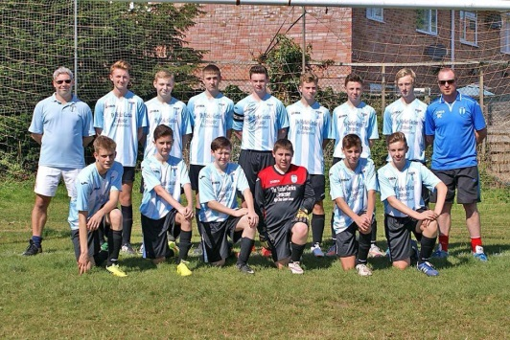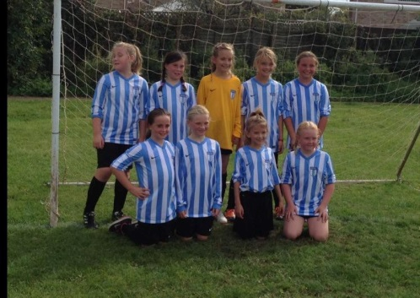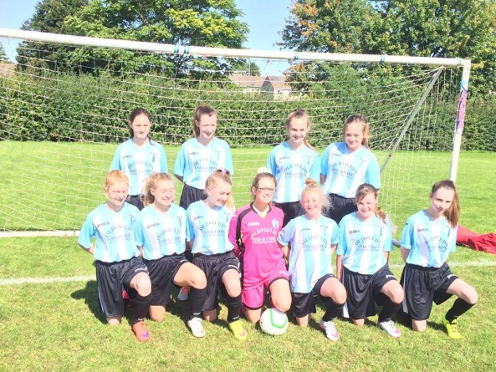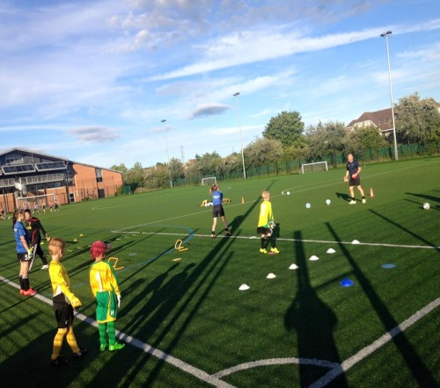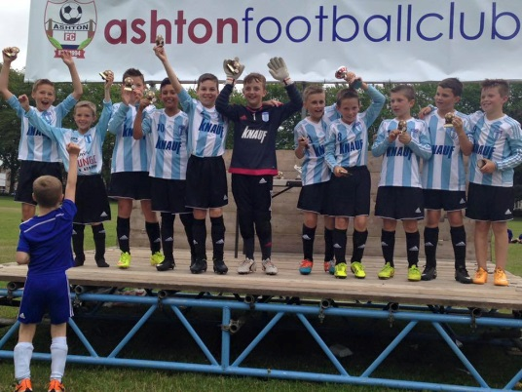

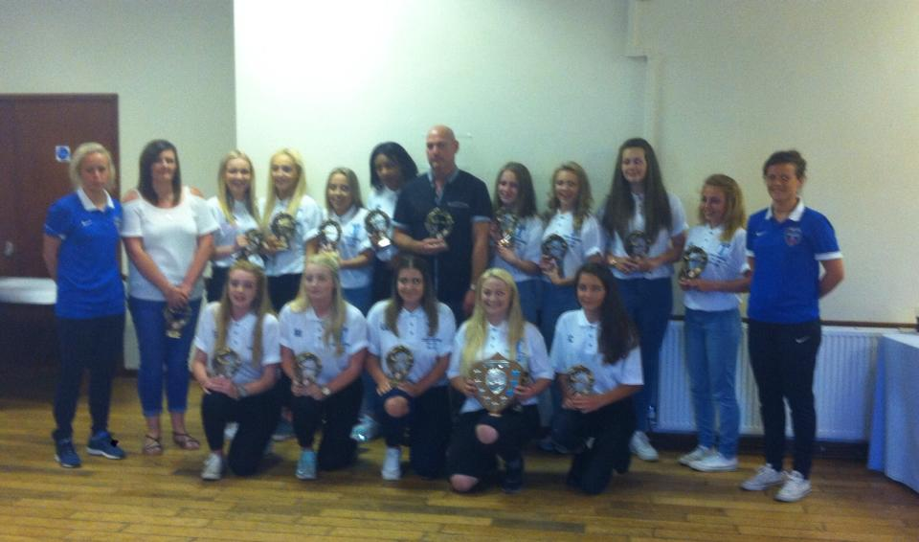

Last years under 16 girls (current under 18 girls) at the Bristol Girls League Annual presentation, collecting their league winners’ trophies.